Multi-agency Home Environment Assessment Tool
Name of family: |  |  |  |  |  | Name(s) and age(s) of children: |  |  | 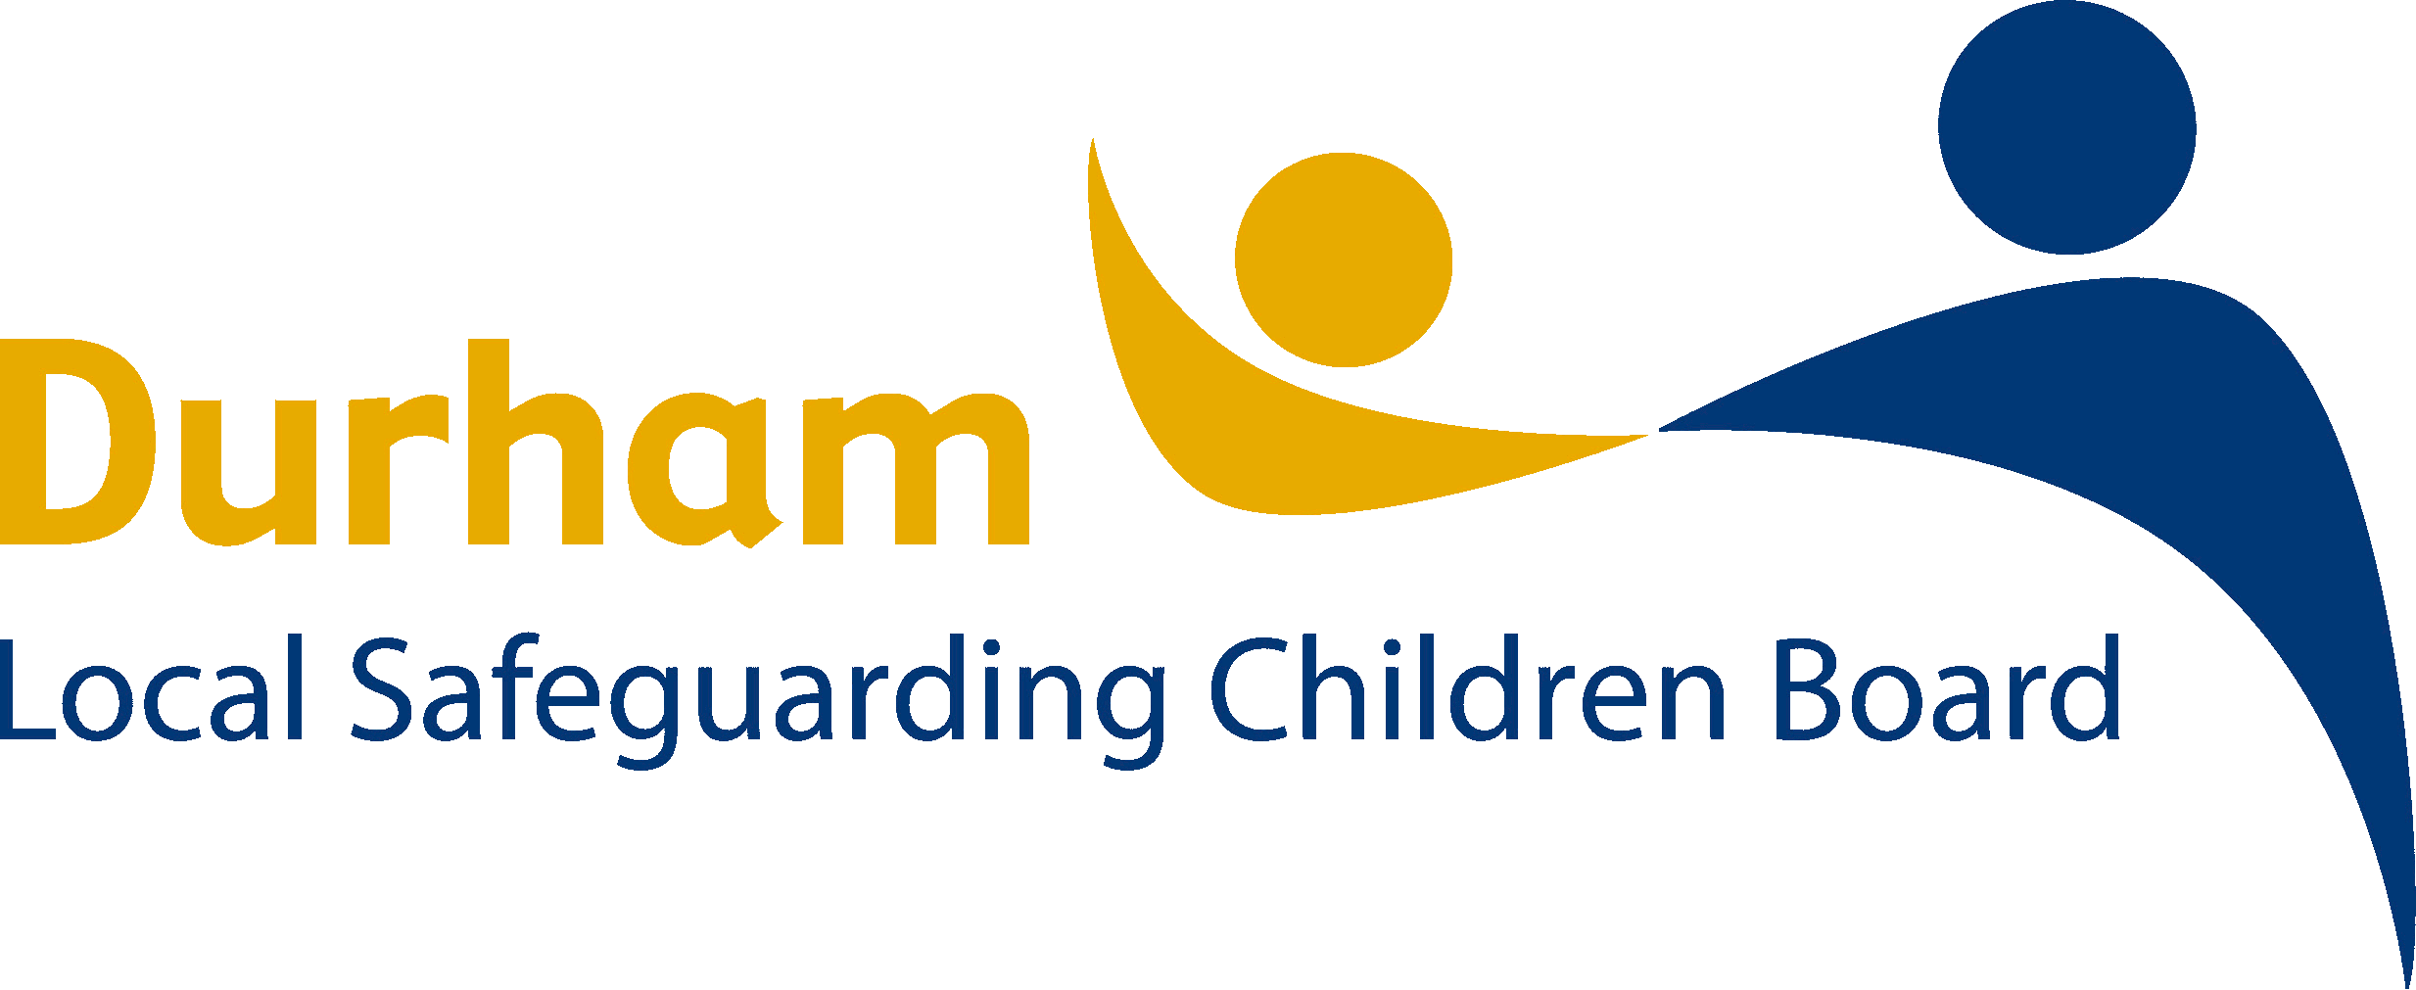
Date of assessment:
Was the visit announced? |  | yes no
Practitioner undertaking assessment: Name |  |  |  |  |  |  | Job title: |  |  | Service
 |  |  | Initial visit date: |  | Impact on child/ren  Specific details (if required)
 |  |  | Yes  (strength) or N/A  (0) | No  (requires  improvement)  (1)
1.0 | Observations of interior and exterior of home
1.1 | Home free from pet/animal hazards including faeces/ vermin.
1.2 | Home free from rubbish/clutter/ hoarding which is likely to pose a safety risk to children.
1.3 | Home in state of good repair.
1.4 | Adequate home furnishings.
1.5 | Adequate basic amenities including services to kitchen and bathroom.
1.6 | Basic kitchen items and provisions appropriate to children and family (eg. weaning).

 |  | Initial visit date: |  | Impact on child/ren  Specific details (if required)
 |  | Yes  (strength) or N/A  (0) | No  (requires  improvement)  (1)
2.0 | Health & Safety Issues
2.1 | Safe home environment clear of hazards and age appropriate safety equipment present.
2.2 | Home is warm, well ventilated and pleasant odour.
2.3 | No evidence of exposed needles/ drug paraphernalia/ medicines/alcohol in sight or reach of children.
2.4 | Evidence of animals in the home being well cared for and supervised around the child/ren. The dog is not considered dangerous and / or there is not a history of dog bites?
2.5 | Smoke alarms and carbon monoxide alarms present and in working order.
3.0 | Sleeping Arrangements
3.1 | Safe sleeping environment.
3.2 | Beds and furnishings clean and in good state of repair.
3.3 | Mattress and bedclothes on children’s bed.
3.4 | No evidence of locks/bolts on outside of bedroom doors.
 |  | Initial visit date: |  | Impact on child/ren  Specific details (if required)
 |  | Yes  (strength) or N/A  (0) | No  (requires  improvement)  (1)
4.0 | Care of babies/young children
4.1 | Evidence of sterilizing equipment/baby milk/nappies.
4.2 | Evidence of age appropriate toys.
4.3 | Evidence of babies/ young children being offered space and freedom to play.
4.4 | Evidence of age appropriate supervision (also consider age appropriate babysitters )
5.0 | Child appearance/demeanour/health
5.1 | Child displays happy/sociable/ active behaviour appropriate to age.
5.2 | Child seen to have clean skin/nails/hair/ clothes.
5.3 | No evidence of head lice/other infestation.
5.4 | No evidence of bald patches/cold extremities.
5.5 | The child has access to a toothbrush and visits a dentist regularly. Child has no dental pain / toothache.

 |  | Initial visit date: |  | Impact on child/ren  Specific details (if required)
 |  | Yes  (strength) or N/A  (0) | No  (requires  improvement)  (1)
5.6 | No evidence child underweight/ overweight.
5.7 | Child appropriately dressed for weather in well-fitting clothes
5.8 | Child exhibits social behaviour appropriate to age.
6.0 | Parental behaviour
6.1 | Parents responsive to child’s needs.
6.2 | Parents responsive to child’s requests for attention/ affection/help.
6.3 | Parents have realistic  expectations of the child.
6.4 | Family budgeting meets child’s needs
7.0 | Any other issues or observations the practitioner or family member wishes to raise?
7.1

