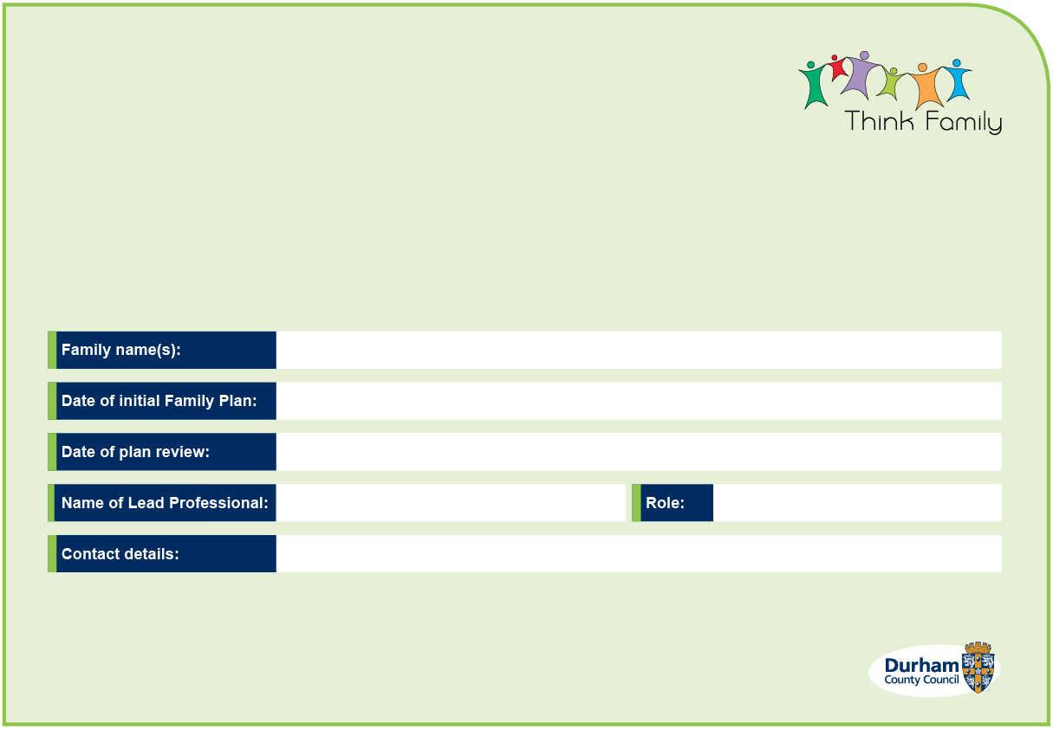
Family Plan

Top of Form
Team around the family:
To add in another family member or named professional please insert row below
Name of family member | Position in family  (e.g. mother, son, grandmother) | Contact details | Attended? | Contributed if not attended?
 |  |  | Yes ☐ No ☐ | Yes ☐ No ☐
 |  |  | Yes ☐ No ☐ | Yes ☐ No ☐
 |  |  | Yes ☐ No ☐ | Yes ☐ No ☐
 |  |  | Yes ☐ No ☐ | Yes ☐ No ☐
 |  |  | Yes ☐ No ☐ | Yes ☐ No ☐
 |  |  | Yes ☐ No ☐ | Yes ☐ No ☐
Named Professional | Team/Agency | Contact details | Attended? | Contributed if not attended?
 |  |  | Yes ☐ No ☐ | Yes ☐ No ☐
 |  |  | Yes ☐ No ☐ | Yes ☐ No ☐
 |  |  | Yes ☐ No ☐ | Yes ☐ No ☐
 |  |  | Yes ☐ No ☐ | Yes ☐ No ☐
 |  |  | Yes ☐ No ☐ | Yes ☐ No ☐
 |  |  | Yes ☐ No ☐ | Yes ☐ No ☐

Summary of family outcomes (Things we want to achieve) To add another outcome below please insert row
1.
2.
3.
4.
Goal number: |  |  | Family member:
What goal (small change) do we want to achieve? |  | How will we do this? | Who | When | What’s been achieved so far? | What will happen next?
 |  |  |  |  |  | Outcomes achieved ☐
Goal number: |  |  | Family member:
What goal (small change) do we want to achieve? |  | How will we do this? | Who | When | What’s been achieved so far? | What will happen next?
 |  |  |  |  |  | Outcomes achieved ☐
Bottom of Form

Goal number: |  | Family member:
What goal (small change) do we want to achieve? | How will we do this? | Who | When | What’s been achieved so far? | What will happen next?
 |  |  |  |  | Outcomes achieved ☐
Goal number: |  | Family member:
What goal (small change) do we want to achieve? | How will we do this? | Who | When | What’s been achieved so far? | What will happen next?
 |  |  |  |  | Outcomes achieved ☐
Goal number: |  | Family member:
What goal (small change) do we want to achieve? | How will we do this? | Who | When | What’s been achieved so far? | What will happen next?
 |  |  |  |  | Outcomes achieved ☐
To add additional goals please copy and paste above section
Family Progress Summary
To be agreed by members of the Team around the Family and updated at each meeting.
(Please review in conjunction with the County Durham Family Outcomes Framework)
Criteria met |  | Good positive change | Some limited change | No positive change | Not needed for this family | Outcomes achieved | Source of Evidence  (how do we know)
Education |  | ☐ | ☐ | ☐ | ☐ | ☐
Crime/ Anti-Social Behaviour |  | ☐ | ☐ | ☐ | ☐ | ☐
Employment/NEET |  | ☐ | ☐ | ☐ | ☐ | ☐
Domestic Abuse |  | ☐ | ☐ | ☐ | ☐ | ☐
Child who needs help |  | ☐ | ☐ | ☐ | ☐ | ☐
Health Needs |  | ☐ | ☐ | ☐ | ☐ | ☐
Other |  | ☐ | ☐ | ☐ | ☐ | ☐
Other |  | ☐ | ☐ | ☐ | ☐ | ☐
Other |  | ☐ | ☐ | ☐ | ☐ | ☐
Views of the
child/ren
Views of the
mother, father, carers
Views of the
professionals
New Plan
Goal number: |  | Family member:
What goal (small change) do we want to achieve? | How will we do this? | Who | When | What’s been achieved so far? | What will happen next?
 |  |  |  |  | Outcomes Achieved ☐
Goal number: |  | Family member:
What goal (small change) do we want to achieve? | How will we do this? | Who | When | What’s been achieved so far? | What will happen next?
 |  |  |  |  | Outcomes Achieved ☐
Goal number: |  | Family member:
What goal (small change) do we want to achieve? | How will we do this? | Who | When | What’s been achieved so far? | What will happen next?
 |  |  |  |  | Outcomes Achieved ☐

Goal number: |  | Family member:
What goal (small change) do we want to achieve? | How will we do this? | Who | When | What’s been achieved so far? | What will happen next?
 |  |  |  |  | Outcomes Achieved ☐
Goal number: |  | Family member:
What goal (small change) do we want to achieve? | How will we do this? | Who | When | What’s been achieved so far? | What will happen next?
 |  |  |  |  | Outcomes Achieved ☐
Goal number: |  | Family member:
What goal (small change) do we want to achieve? | How will we do this? | Who | When | What’s been achieved so far? | What will happen next?
 |  |  |  |  | Outcomes Achieved ☐

What needs to happen next?
The Family Plan will be revised and shared with family and TAF members |  | By Who: | When:
Family Plan continues to be reviewed (please enter review/Team around the Family review date) |  |  | Date:
Undertake Engaging Families Toolkit |  | Reason:
Escalation | Date: | Reason:
De-escalation | Date: | Reason:
Change of lead professional: |  | Reason:
All goals and outcomes achieved, case closure |  | Date:
Declaration of outcomes to Think Family Team: |  |  | Date:
Signature of Lead Professional: |  |  | Date:
Signature Parent/Carer: |  |  | Date:
Signature Young Person (if appropriate): |  |  | Date:
Name and signature of Manager: |  |  | Date:

